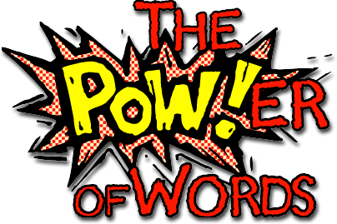**2021-2022 Kindergarten Sight Words**

**Quarter 1 words:_**____/ 21

|  |  |  |  |  |
| --- | --- | --- | --- | --- |
| I | am | the | like | to |
| a | have | is | he | my |
| we | make | for | me | with |
| see | she | look | are | that |
| of |  |  |  |  |

**Quarter 2 words:**  ______ /27

|  |  |  |  |  |
| --- | --- | --- | --- | --- |
| they | you | do | one | two |
| three | four | five | here | go |
| from | yellow | blue | green | what |
| said | was | where | come | play |
| any | down | her | how | away |
| give | little |  |  |  |

**Quarter 3 words:**  ______ / 25

|  |  |  |  |  |
| --- | --- | --- | --- | --- |
| funny | were | some | going | know |
| live | find | again | over | pretty |
| all | now | black | brown | white |
| good | could | open | please | want |
| every | may | this | round |  |

**Quarter 4 words:**  _____ /18

|  |  |  |  |  |
| --- | --- | --- | --- | --- |
| be | saw | our | eat | soon |
| walk | who | there | into | out |
| so | then | new | too | when |
| no | say | under |  |  |